**Segment Tree Min-Max**

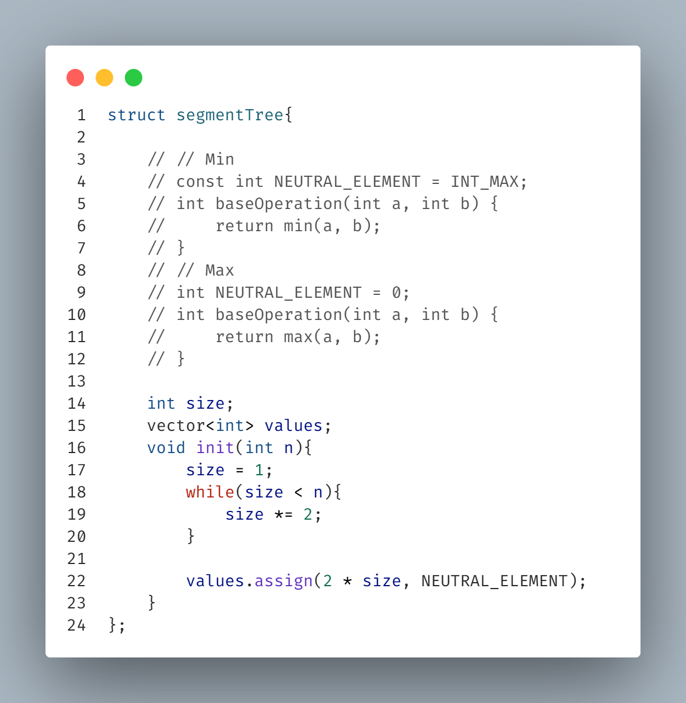**\\ Base code //**

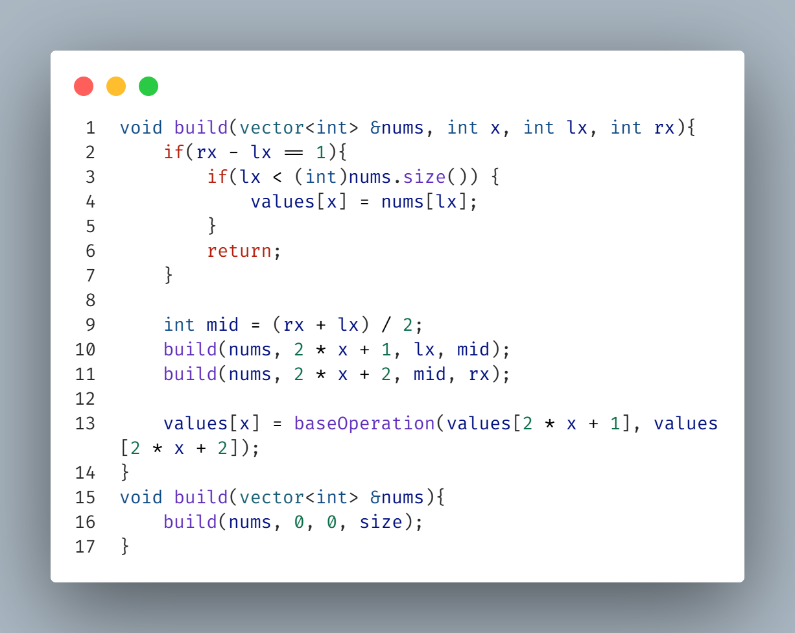**\\ Build Code //**

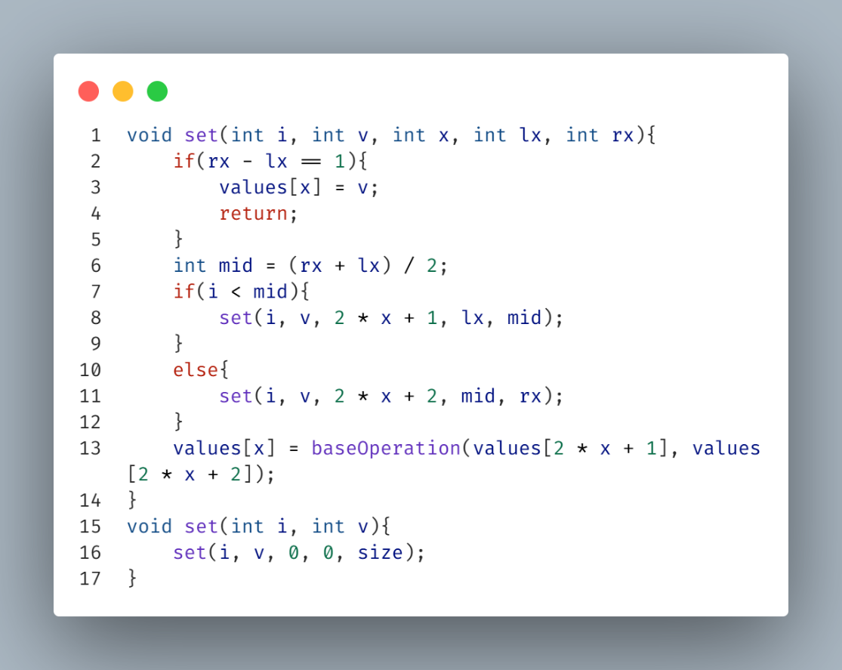**\\ Set Code //**

**\\ Get Code //**

**\\ Set Range Code //**

**Get First Index of an element in range less than a value (v)**

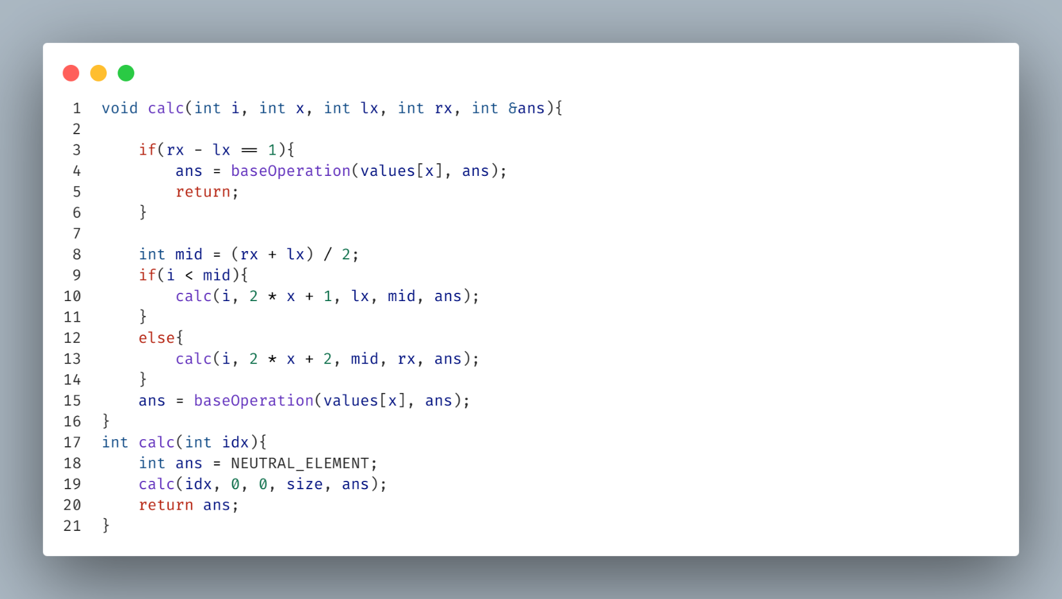**\\ Calc Code [ get value from setRange() ] //**

**Get Last Index of an element in range less than a value (v)**

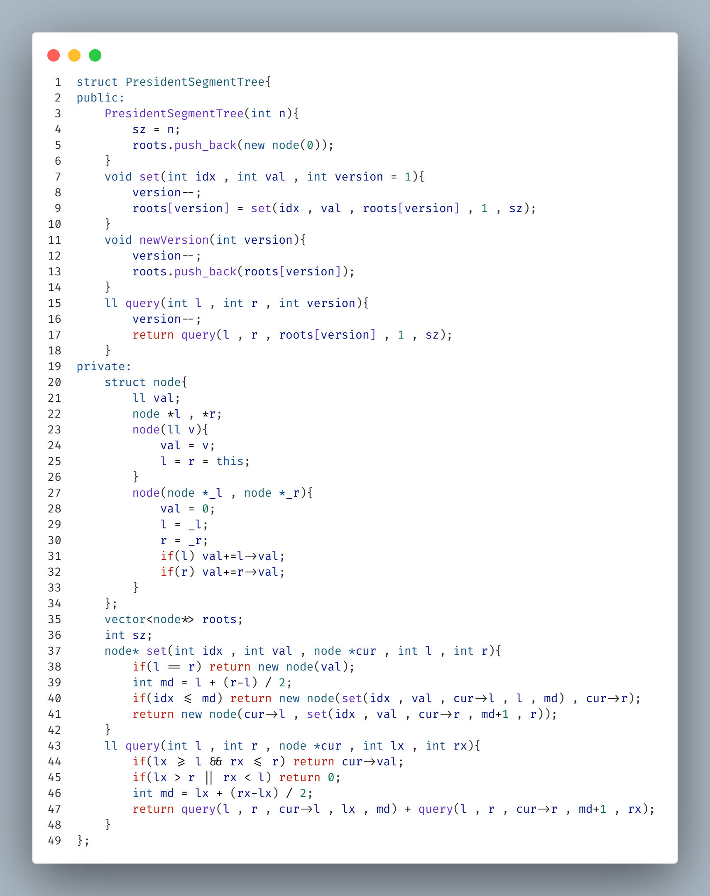**President Segment Tree**